**Finding new and repeat customers in the customer table in database**

Here we will write sql query to find the whether the customer is new or repeated customer

Below is the customer table in DB

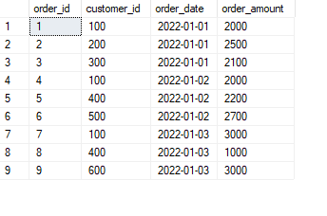

We will write optimized query to get first_visit_customer_flag and repeat_visit_customer_flag

If the flag is 1 then true 0 means false that is first_visit_customer_flag = 1 means new customer.

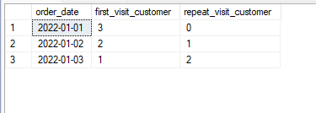

We can use same to check the amount whether it is first_visit_customer_amount or repeat_visit_customer_amount